Software Requirements Specification

for

Hotel Management System

Version 1.0

Prepared by Venkatesh Prabhu (46)

Vidhi Bansal(53)

<organization>

<date created>

Table of Contents

Table of Contents ii

Revision History ii

1. Introduction 1

1.1 Purpose 1

1.2 Document Conventions 1

1.3 Intended Audience and Reading Suggestions 1

1.4 Product Scope 1

1.5 References 1

2. Overall Description 2

2.1 Product Perspective 2

2.2 Product Functions 2

2.3 User Classes and Characteristics 2

2.4 Operating Environment 2

2.5 Design and Implementation Constraints 2

2.6 User Documentation 2

2.7 Assumptions and Dependencies 3

3. External Interface Requirements 3

3.1 User Interfaces 3

3.2 Hardware Interfaces 3

3.3 Software Interfaces 3

3.4 Communications Interfaces 3

4. System Features 4

4.1 System Feature 1 4

4.2 System Feature 2 (and so on) 4

5. Other Nonfunctional Requirements 4

5.1 Performance Requirements 4

5.2 Safety Requirements 5

5.3 Security Requirements 5

5.4 Software Quality Attributes 5

5.5 Business Rules 5

6. Other Requirements 5

Appendix A: Glossary 5

Appendix B: Analysis Models 5

Appendix C: To Be Determined List 6

Revision History

|  |  |  |  |
| --- | --- | --- | --- |
| **Name** | **Date** | **Reason For Changes** | **Version** |
|  |  |  |  |
|  |  |  |  |

# Introduction

## Purpose

The Software Requirement Specification will provide a detailed description of the requirements for Hotel Management System. This gives a comprehensive view of how the system is supposed to work and what is expected by the end users. Client’s expectation and requirements are analyzed to produce functional and nonfunctional requirements. The clear understanding of the system and its functionality will allow for the correct software to be developed for the end user.

## Document Conventions

The document is prepared using Microsoft Word 2013 and has font type ‘Times New Roman’. The fixed font size that has been used to type this document is 11pt. It has used the bold property with text size 14pt to set the headings of the document.

## Intended Audience and Reading Suggestions

This document is intended for all individuals participating in and/or supervising Hotel Management Project. Readers interested in a brief overview of the product should focus on the rest of Part 1 (Introduction), as well as Part 2 (Overall Description), which provides a brief overview of each aspect of the project as a whole.

Readers who wish to explore the features of Hotel Management Software in more detail should read on Part 4 (System Features), which expands upon the information laid out in the main overview. Part 3 (External Interface Requirements) offers further technical details, including information on the user interface as well as the hardware and software platforms on which the application will run.

Readers interested in the non-technical aspects of the project should read Part 5, which covers performance, safety, security, and various other attributes that will be important to users.

## Product Scope

The Hotel Management System will automate hotel operations. The first subsystem is Reservation and Booking System to keep track of reservations and room availability. The second subsystem is managing the restaurant orders for the corresponding booked room. The third subsystem is a General Management Services and automated Tasks System which generates reports to audit hotel operations availed by the guests.

There are two end users for HMS. The end users are the hotel managers and hotel customers (guests). Both users can access Reservation and Booking System and the Food Ordering System. The General Management System will be restricted to the management users.

The Hotel Management System’s objectives is to provide a system to manage a hotel that has increased in size to a total of 100 rooms. Without automation the management of the hotel has become an unwieldy task.

With the help of this system the end user’s day to day jobs of managing a hotel will be simplified by a considerable amount through the automated system. The system will be able to handle many services to take care of all customers in a real quick manner. So basically, the tedious job of handling and managing loads of physical files can be eliminated and thus providing indeed an efficient way to manage the Hotel audit.

## References

Hotel Management Software: <https://documents.mx/documents/srs-for-hotel-management-system.html>

UML Models: <https://www.lucidchart.com/pages/use-case-diagram-for-hotel-management-system-UML>

Requirement Engineering: <https://www.tutorialspoint.com/software_testing_dictionary/software_requirement_specification.htm>

# Overall Description

## Product Perspective

The project has been catalyzed as a need to serve Hotel Management System with an ease to manage the guests and avoid loads of paper work. The software is indeed a brilliant replacement of the manual physical record keeping systems of hotel. The HMS project is a new, self-contained product intended for use on the Windows platform. The scope of the project encompasses customer side and manager side functionalities, so both aspects are covered in detail within this document.

## Product Functions

* Login Administrator
* Customer Registration
* Search available room
* Display Booking Details
* Display Food Menu
* Restaurant Service Details
* Payment
* Confirmation of Booking
* Delete Guest
* Change Guest Information
* Customer Search
* Customer Service
* Set Room Details
* Email notification

## User Classes and Characteristics

### Administrator

Administrator monitors and authorizes the task handled by the system. Administrator has access to administration panel which is considered the core of the system. As the head of the company/software administrator gets the ability to manage other users including their user levels. He will also be able to take all kinds of report available in the system. Administrator also has the power to set room rates.

### Guests

Guests can reserve room/s, search for availability and book rooms at their own convenience. Customers are an important entity of Hotel Management System as components directly or indirectly revolve around them.

Guest users can select suitable dates and manage their booking with the privilege of selecting the room type and convenient payment options.

### Hotelier

Manager upkeeps sanitary standards of hotel facilities, guest satisfaction and customer service, marketing management, purchasing and other functions. They coordinate the front desk operations and tracks the guests to ensure their comfortable stay. Hotelier manages the reservation revenue and meal revenue, keeps track of the pending payment of respective room numbers and generates the total due at the time of check out.

## Operating Environment

The main component of the Hotel Management project is the software application, which will be limited to the Windows operating system. The system is not resource or graphics intensive, so no practical hardware constraints.

The Hotel Management Database will be stored using MySQL and will be interfaced with a wrapper written in Java.

## Design and Implementation Constraints

Creating user interface which is both effective and easily navigable will pose a difficult challenge. Other constraints such as limited memory and processing power are also worth considering. Hotel Management Software is meant to be quick and responsive, even when dealing with large groups and transactions, so each feature must be designed and implemented with efficiency in mind.

## User Documentation

The primary goal of HMS is to facilitate the process of managing Hotel. Consequently, the system will be designed to be as simple as possible. Nonetheless, users may still require some supplementary information about each component of HMS. The system will contain feature that offer this: Help Menu.

The Help Menu is a collection of topics covering each of the system’s menus, features etc. At any time the user can navigate to the help menu and select any of these topics to obtain more information.

## Assumptions and Dependencies

<List any assumed factors (as opposed to known facts) that could affect the requirements stated in the SRS. These could include third-party or commercial components that you plan to use, issues around the development or operating environment, or constraints. The project could be affected if these assumptions are incorrect, are not shared, or change. Also identify any dependencies the project has on external factors, such as software components that you intend to reuse from another project, unless they are already documented elsewhere (for example, in the vision and scope document or the project plan).>

### Hardware Dependencies

# External Interface Requirements

## User Interfaces

|  |  |
| --- | --- |
| **Screen Name** | **Description** |
| Login | Login into the system as Administrator or Manager |
| Reservation | Retrieve button, update/save reservation, cancel reservation, modify reservation, accept payment type |
| Check-in | Modify room stay, check in customer (with or without reservation), special requests, accept payment type |
| Checkout | Checkout customer, generate bill |
| Hotel Payment | Accept payment for room and meals |
| Room Service/Meals | Create order, modify order, cancel order, generate meal bill |
| Customer Record | Add or update customer records |
| Search | Look for the availability of room and availability on given check-in date |

## Hardware Interfaces

<Describe the logical and physical characteristics of each interface between the software product and the hardware components of the system. This may include the supported device types, the nature of the data and control interactions between the software and the hardware, and communication protocols to be used.>

## Software Interfaces

The HMS is to be developed under the Windows OS using Java and MySQL.

### Incoming and Outing Items

* Outgoing data consists of bills, transactions.
* Incoming data consists of new user registrations, meal orders, as well as extra amenities info.

### Services and Communications

### Communication will occur in occasional, short bursts between user’s phone and the server in the following situation:

* Whenever a user registers/confirm a new bill or transaction

## Communications Interfaces

<Describe the requirements associated with any communications functions required by this product, including e-mail, web browser, network server communications protocols, electronic forms, and so on. Define any pertinent message formatting. Identify any communication standards that will be used, such as FTP or HTTP. Specify any communication security or encryption issues, data transfer rates, and synchronization mechanisms.>

# System Features

Functional requirements define the fundamental actions that system must perform.

## Login

### Description

The system should allow managers and receptionist to login to the system.

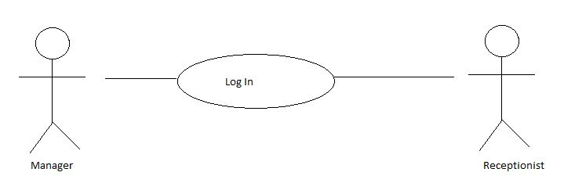

### Stimulus/Response

* Enter e-mail id/username
* Enter password

### Functional Requirements

1. The system shall verify the email and password against the member database when logging in.
2. The system shall allow the user to login to their registered account.
3. On logging in, the system shall allow manager to access customer’s details.
4. On logging in, the system shall allow receptionist to manage bookings and look after the availability of the vacant rooms.

## Make Reservations

### Description

### This is used to make reservations of rooms by the customers. The reservation made by the customer will be stored in the database for future references.

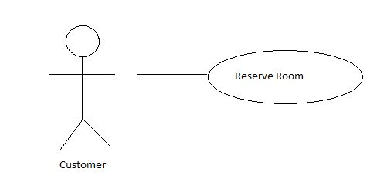

### Stimulus/Response Sequences

To stimulate reservation user is asked to input the following:

* Enter Customer Name
* Enter Customer Contact Number
* Enter Number of Adults
* Enter Number of children
* Enter Check-in-date
* Enter Check-out-date
* Select Room Type
* Select Number of Rooms

### Functional Requirements

REQ-1: The system shall record reservations by storing the details entered by the customer.

REQ-2: The system shall check for the availability of desired room type and required number of vacant rooms.

REQ-3: The system shall ask the user to change dates or modify the search results depending on the availability of rooms.

REQ-4: The system shall generate a unique confirmation number for each reservation.

REQ-5: The system shall display the default room rate.

REQ-6: The system shall book the number of rooms specified.

REQ-7: The system shall check-in customers.

REQ-8: The system shall allow reservations to be modified without having to reenter the customer information.

## Meals

### Description

The system allows the user to order meals. It tracks all purchases and charges the respective rooms as necessary.

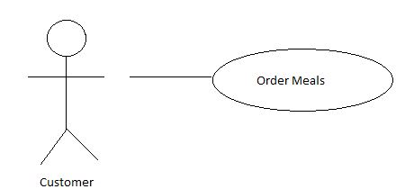

### Stimulus/Responses

* Enter room number
* Enter meal type
* Select food item
* Select payment type
* Confirm and place order

### Functional Requirements

REQ-1: The system shall track all meals purchased in the hotel (restaurant and room service).

REQ-2: The system shall record payment and payment type for meals.

REQ-3: The system shall bill current room if payment is not made at time of service.

REQ-4: The system shall update the bill every time a purchase is made and payment is pending. REQ-5: The system shall allow deletion and modification in the order before confirming the final order.

## Payment

### Description

The system should allow the user to clear the logs by payment through debit card and debit the paid account from the customer dues. Debit card details can be saved by the user for future needs (optional).

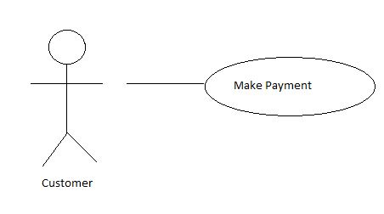

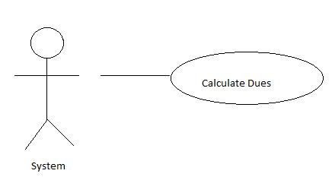

### Stimulus/Responses

* Enter card number
* Enter expiry date
* Enter CVV
* Confirm Amount
* Enter Pin

### Functional Requirements

1. The system shall calculate the dues.
2. The system shall deduct the amount paid from the persisting dues.
3. The system shall save the card details (optional) in the database of the customer for future references.

# Other Nonfunctional Requirements

## Performance Requirements

* Data in database should be updated within 2 seconds.
* Query results must return results within seconds.
* Load time of UI should not take than 2 seconds.
* Login validation should be done within 3 seconds.
* Response to customer inquiry must be done within 5 minutes.

## Safety Requirements

* Database should be backed up every hour.
* Under failure, system should be able to come back at normal operation under an hour.

## Security Requirements

* Customer’s Identification: The system requires the customer to identify himself/herself through phone number.
* Login ID: Any user who login into the system will have a unique user ID and password.
* Modification: Any modification to be done in the database shall be synchronized and done only by the administrator.
* Administrator’s Right: Administrator shall be able to view and modify all the information in the software.
* All external communications between the data’s server and client must be encrypted.
* All data must be stored, protected or protectively marked.
* Payment Process should use HTTP over Secure protocol to secure the payment transactions.

## Software Quality Attributes

The graphical user interface of HMS is to be designed with usability as the first priority. The system will be presented and organized in a manner that is both visually appealing and easy for user to navigate.

To ensure reliability and correctness, there will be zero tolerance for errors in the algorithm that computes the calculation tasks. To maintain feasibility and adaptability, the system will take into account the situations in which a user loses data or for whatever reason data couldn’t be stored in database.

# Other Requirements

<Define any other requirements not covered elsewhere in the SRS. This might include database requirements, internationalization requirements, legal requirements, reuse objectives for the project, and so on. Add any new sections that are pertinent to the project.>

Appendix A: Glossary

<Define all the terms necessary to properly interpret the SRS, including acronyms and abbreviations. You may wish to build a separate glossary that spans multiple projects or the entire organization, and just include terms specific to a single project in each SRS.>

Appendix B: Analysis Models

<Optionally, include any pertinent analysis models, such as data flow diagrams, class diagrams, state-transition diagrams, or entity-relationship diagrams.>

Appendix C: To Be Determined List

<Collect a numbered list of the TBD (to be determined) references that remain in the SRS so they can be tracked to closure.>